Writeup

Kai Li from MRSD

Q1.1

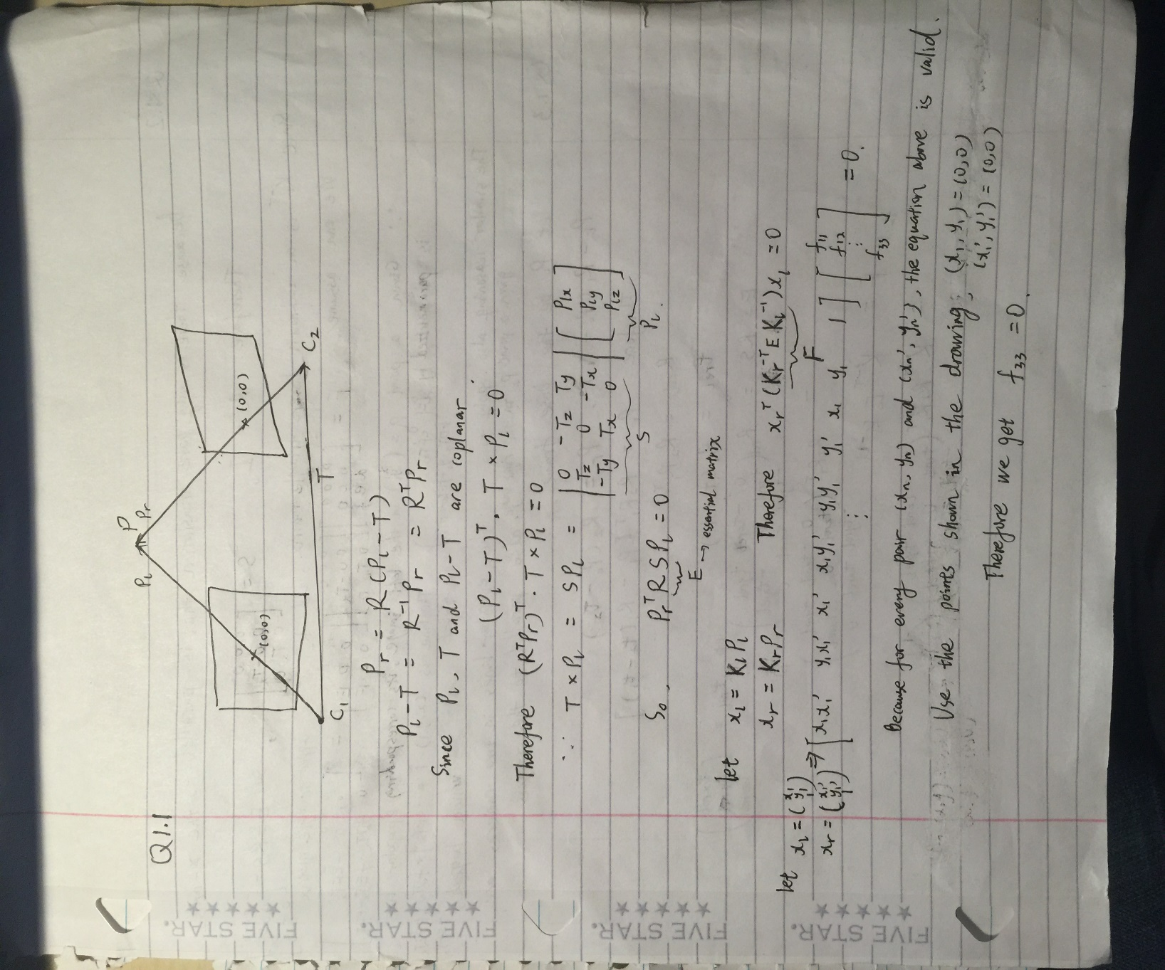

Q1.2 & Q1.3

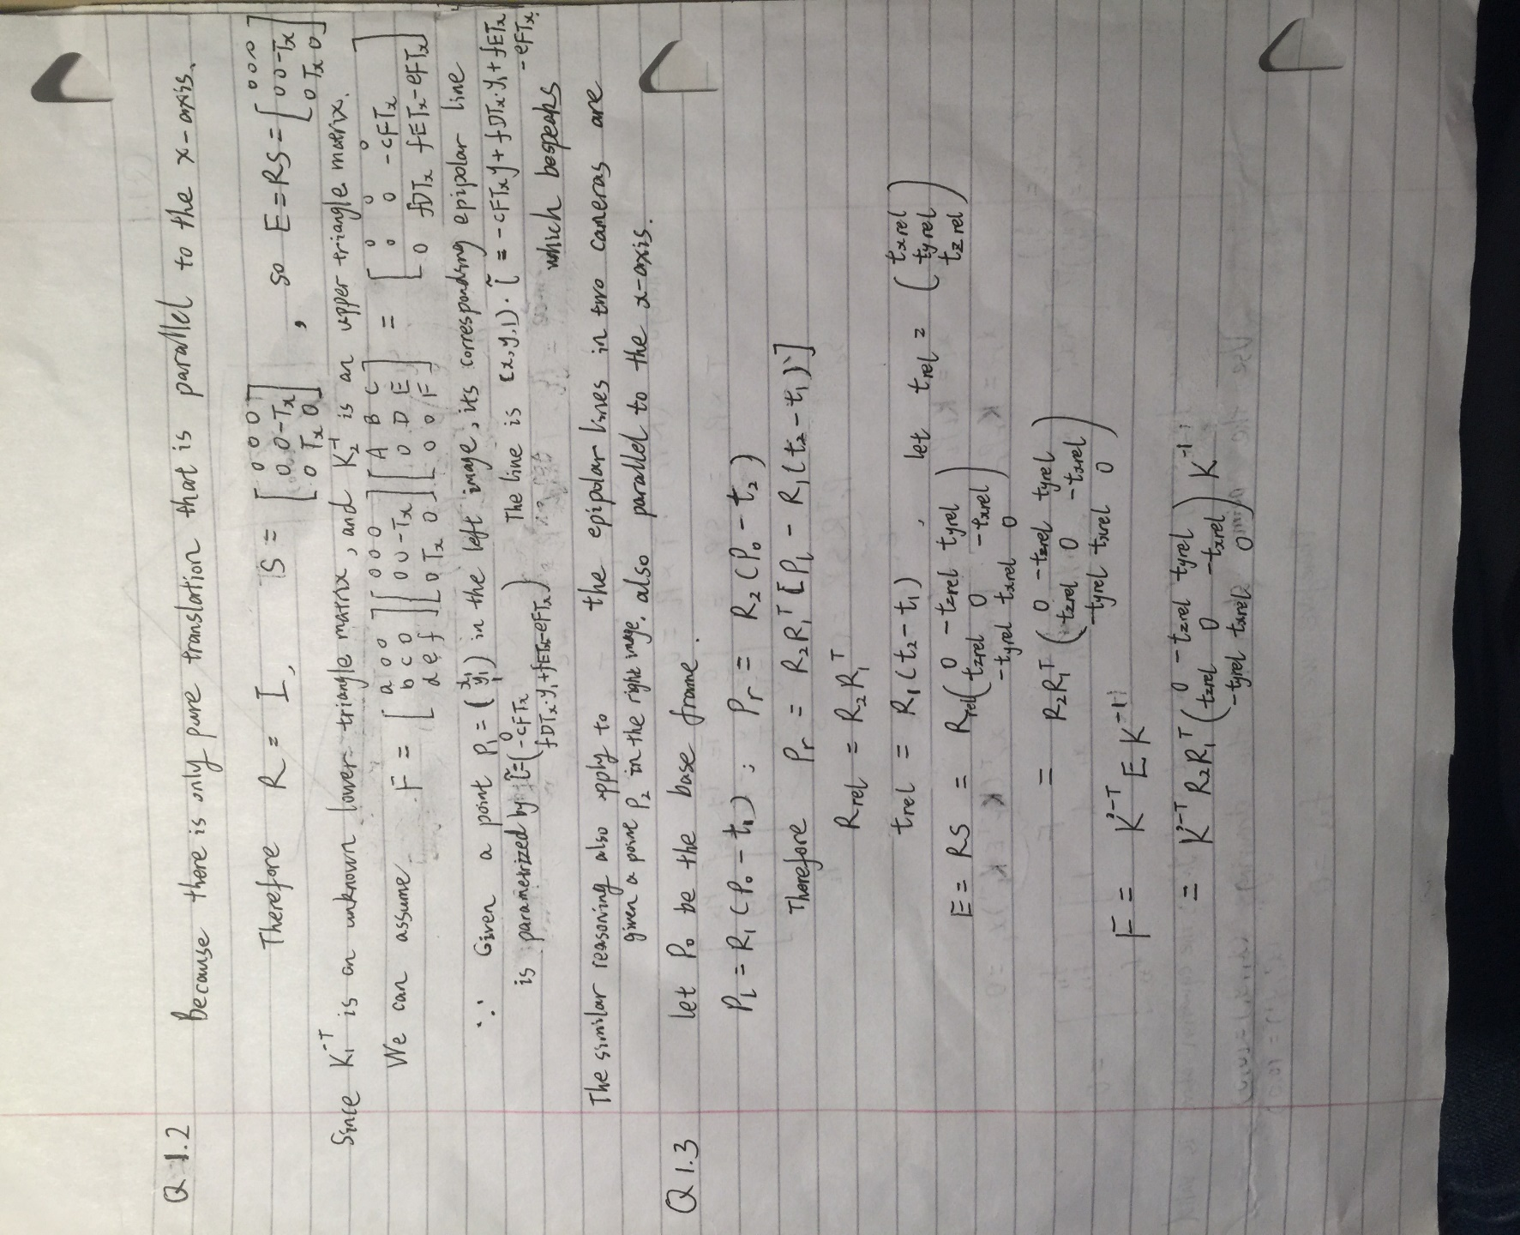

Q1.4

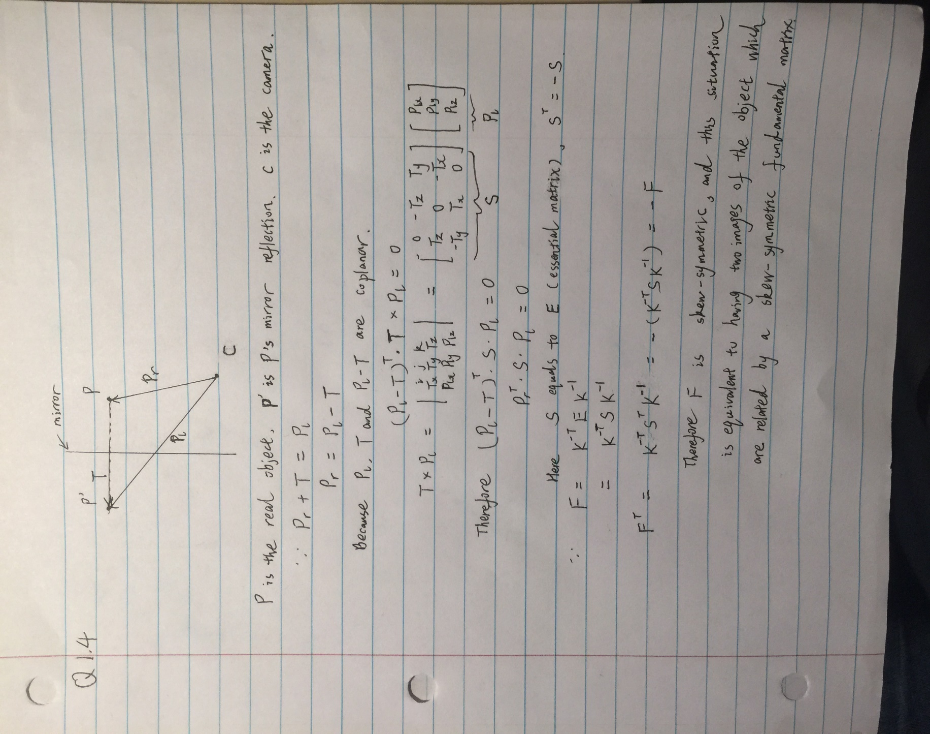

Q2.1

The F matrix is:

F =

-0.0000 -0.0000 0.0022

-0.0000 0.0000 0.0000

-0.0021 0.0000 -0.0092

And the output images are shown below:

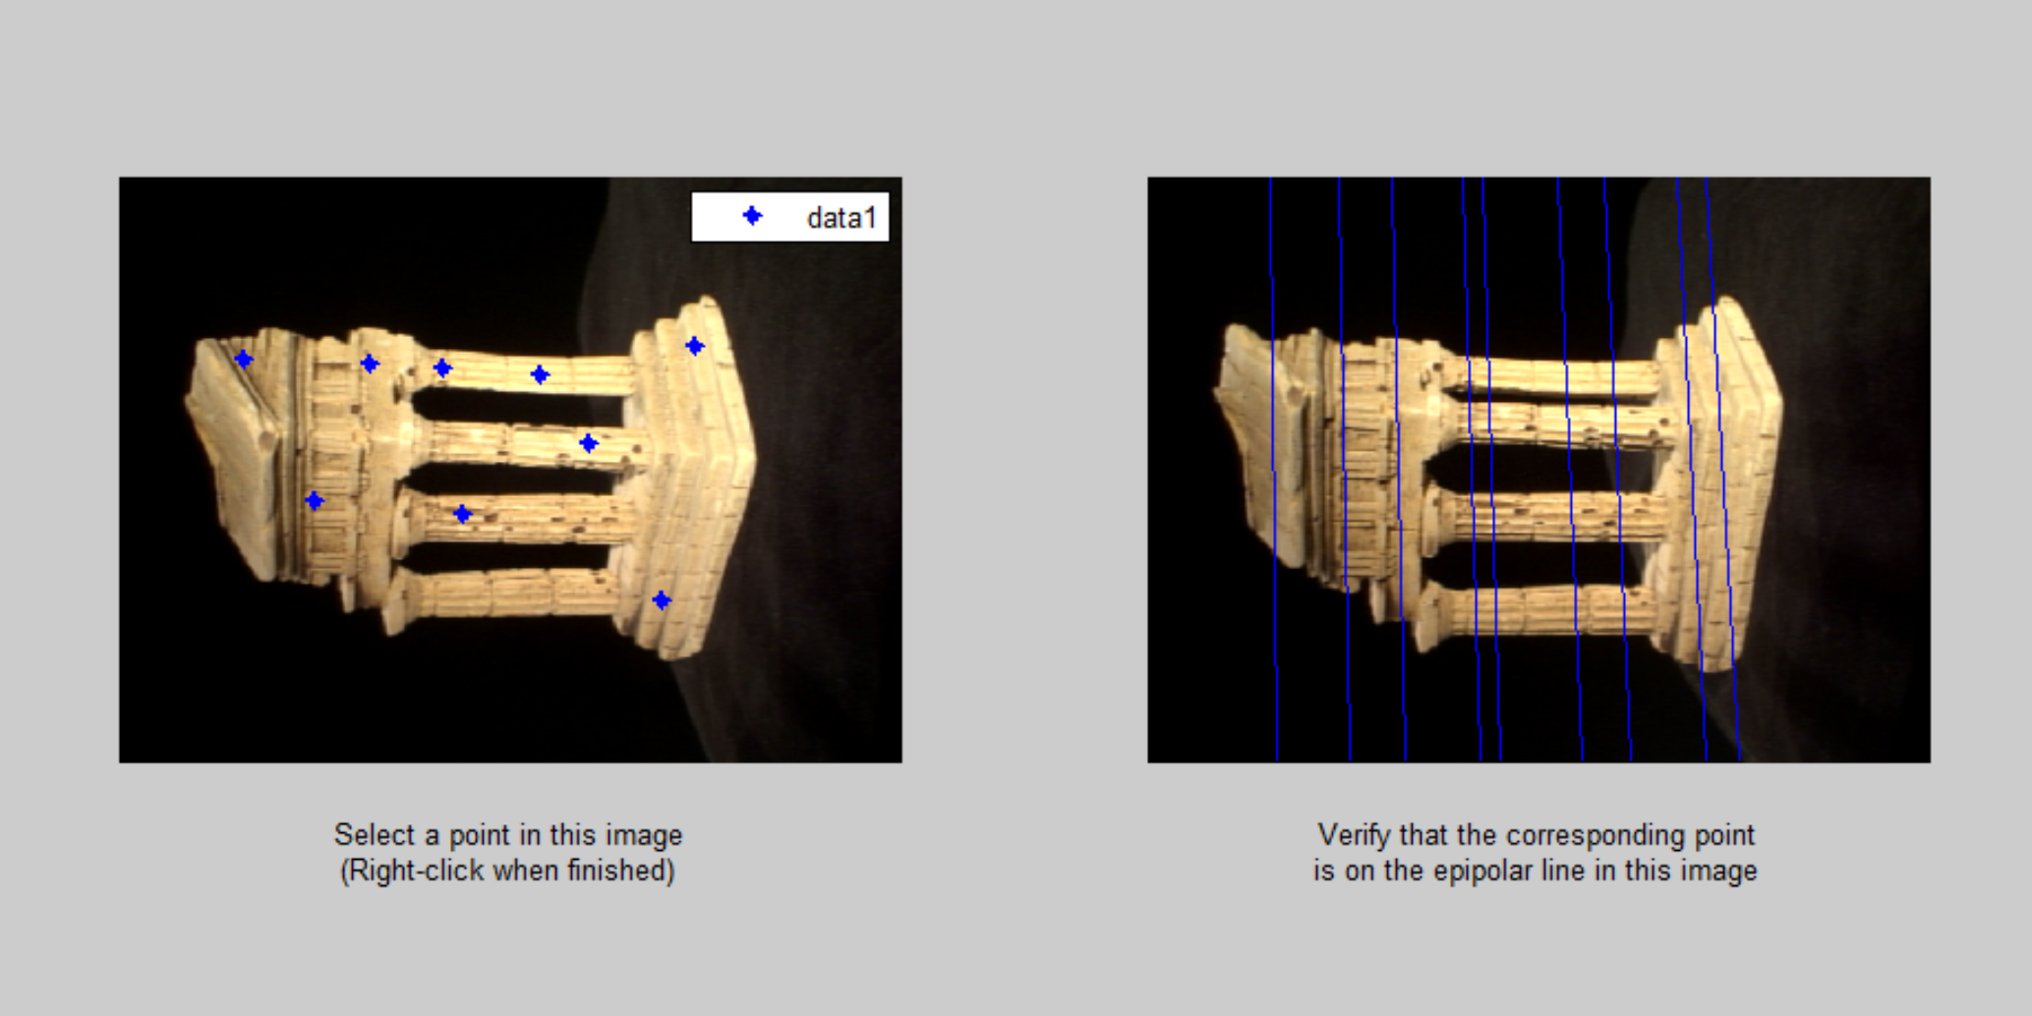

Figure1. The output sample images (eightpoint method)

The detailed code can be referred to eightpoint.m

Q2.2

Use manually selected points with cpselect, I picked:

pts1 =

79.0000 135.5000

228.0000 129.5000

424.0000 224.5000

373.0000 205.5000

423.0000 126.5000

230.0000 318.5000

116.0000 331.5000

pts2 =

78.0000 122.5000

228.0000 133.5000

424.0000 201.5000

373.0000 189.5000

418.0000 134.5000

231.0000 330.5000

118.0000 320.5000

Then using sevenpoint method, I got F:

F =

-0.0000 0.0000 0.0020

-0.0000 -0.0000 0.0004

-0.0019 -0.0004 -0.0003

And the output sample image is:

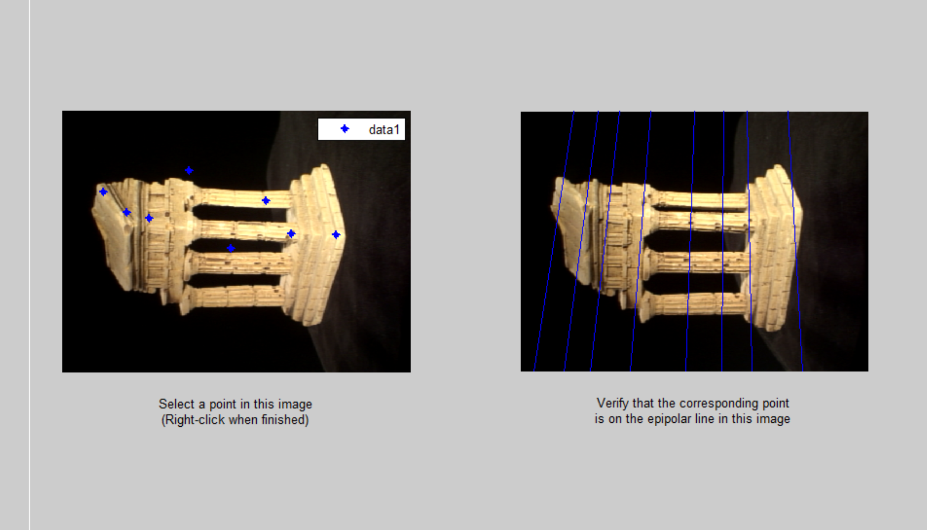

Figure 2. The output sample images (sevenpoint method)

The detailed code can be referred to sevenpoint.m

Q2X (Extra)

The error metrics basically follows the distance from point to epipolar line shown as figure 3:

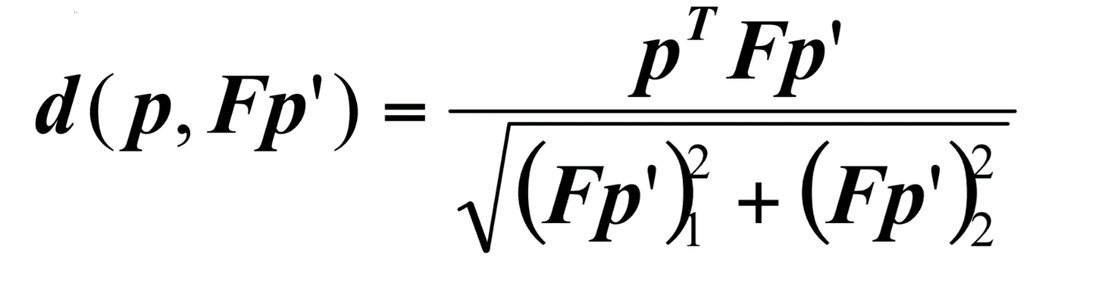

Figure 3. Error metrics for ransacF.m

I set a threshold t = 5e-2; the distance between the point and the mapped epipolar line that within this threshold will make that pair of points as inliers. I first ran the seven point methods with the minimal set of points to formulate F matrix. Then I used the error metrics logic to get the inliers pairs. Whenever the correct pairs’ number reach 75% of the total pairs, I stopped the while loop. Finally, I use eightpoint method on the correct pairs to get the refined F using all the inliers.

F =

0.0000 0.0000 0.0019

-0.0000 0.0000 -0.0001

-0.0019 0.0001 -0.0052

And the output image is:

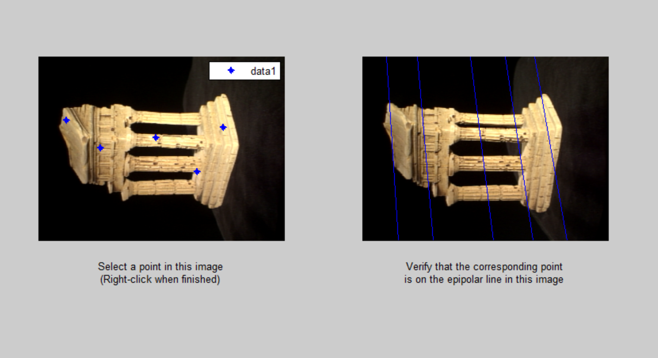

Figure4. The output sample images (ransacF method)

Compared to the output if we use eightpoint method on the noisy coorespondances, see figure 5:

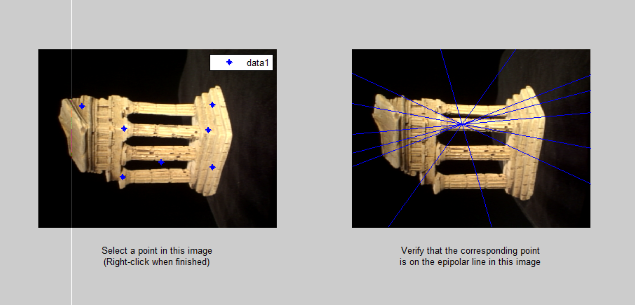

Figure5. The output sample images (eightpoint method on noisy coorespondances)

Therefore we can see after Ransac, the output image looks better! That’s because we got rid of many wrong matching pairs and increased the correct matches possibility. Detailed code can be seen in ransacF.m.

Q2.3

E= K2'*F*K1;

Please see detailed code in essentialMatrix.m

Q2.4

Please refer to triangulate.m for detailed code. And please note that the error term I used here may have different scale as recommended.

Q2.5

Please refer to script findM2.m for details.

Q2.6

Please refer to epipolarCorrespondence.m for more details. And the screenshot of epipolarMatchGUI with some detected correspondences is shown below:

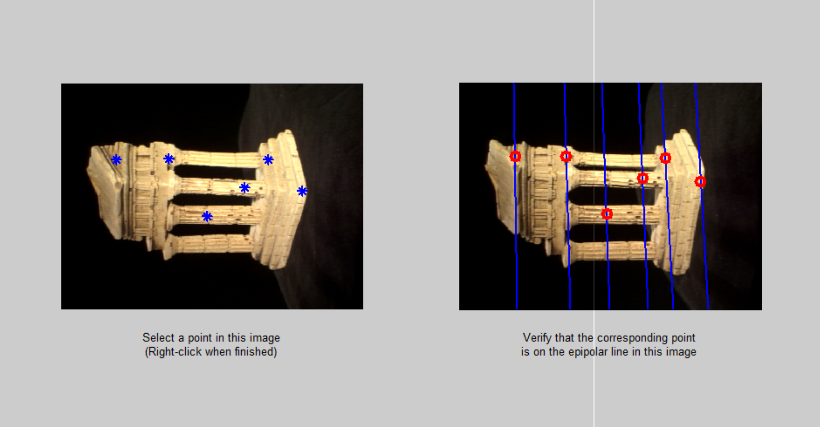

Figure 6. correspondences found by calling epipolarCorrespondence function

Q2.7

The following images are the point cloud I generated. It’s amazing!

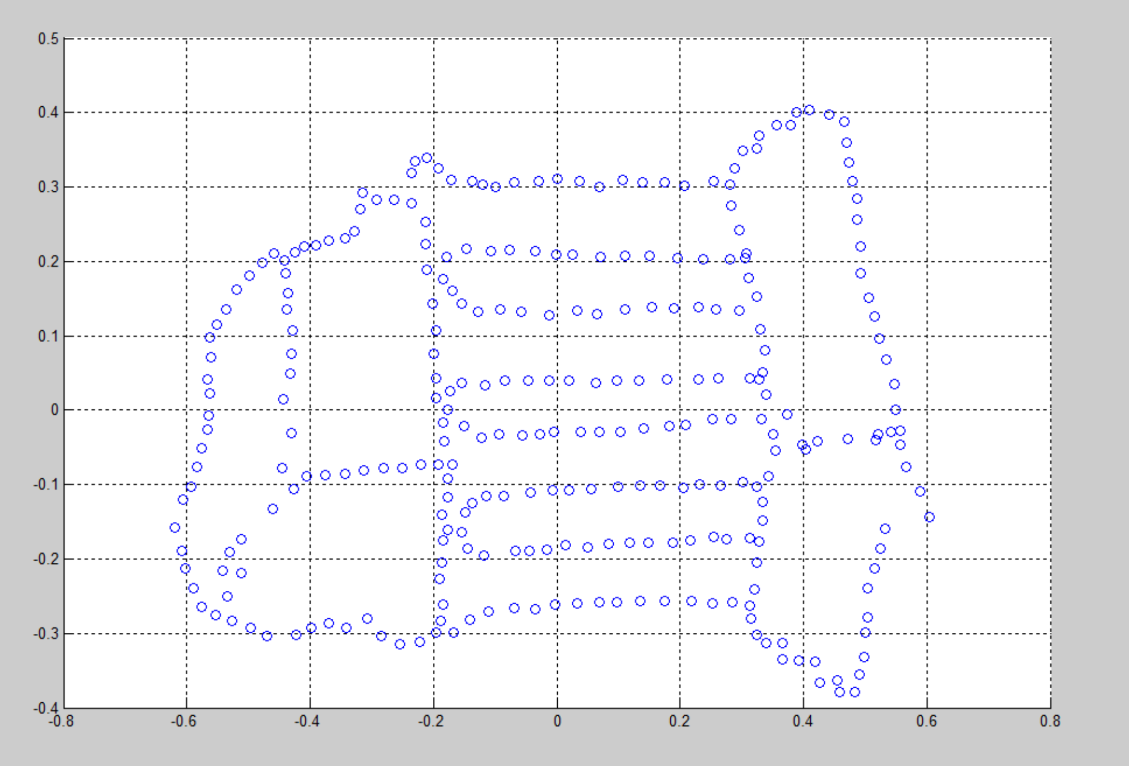

Figure 7

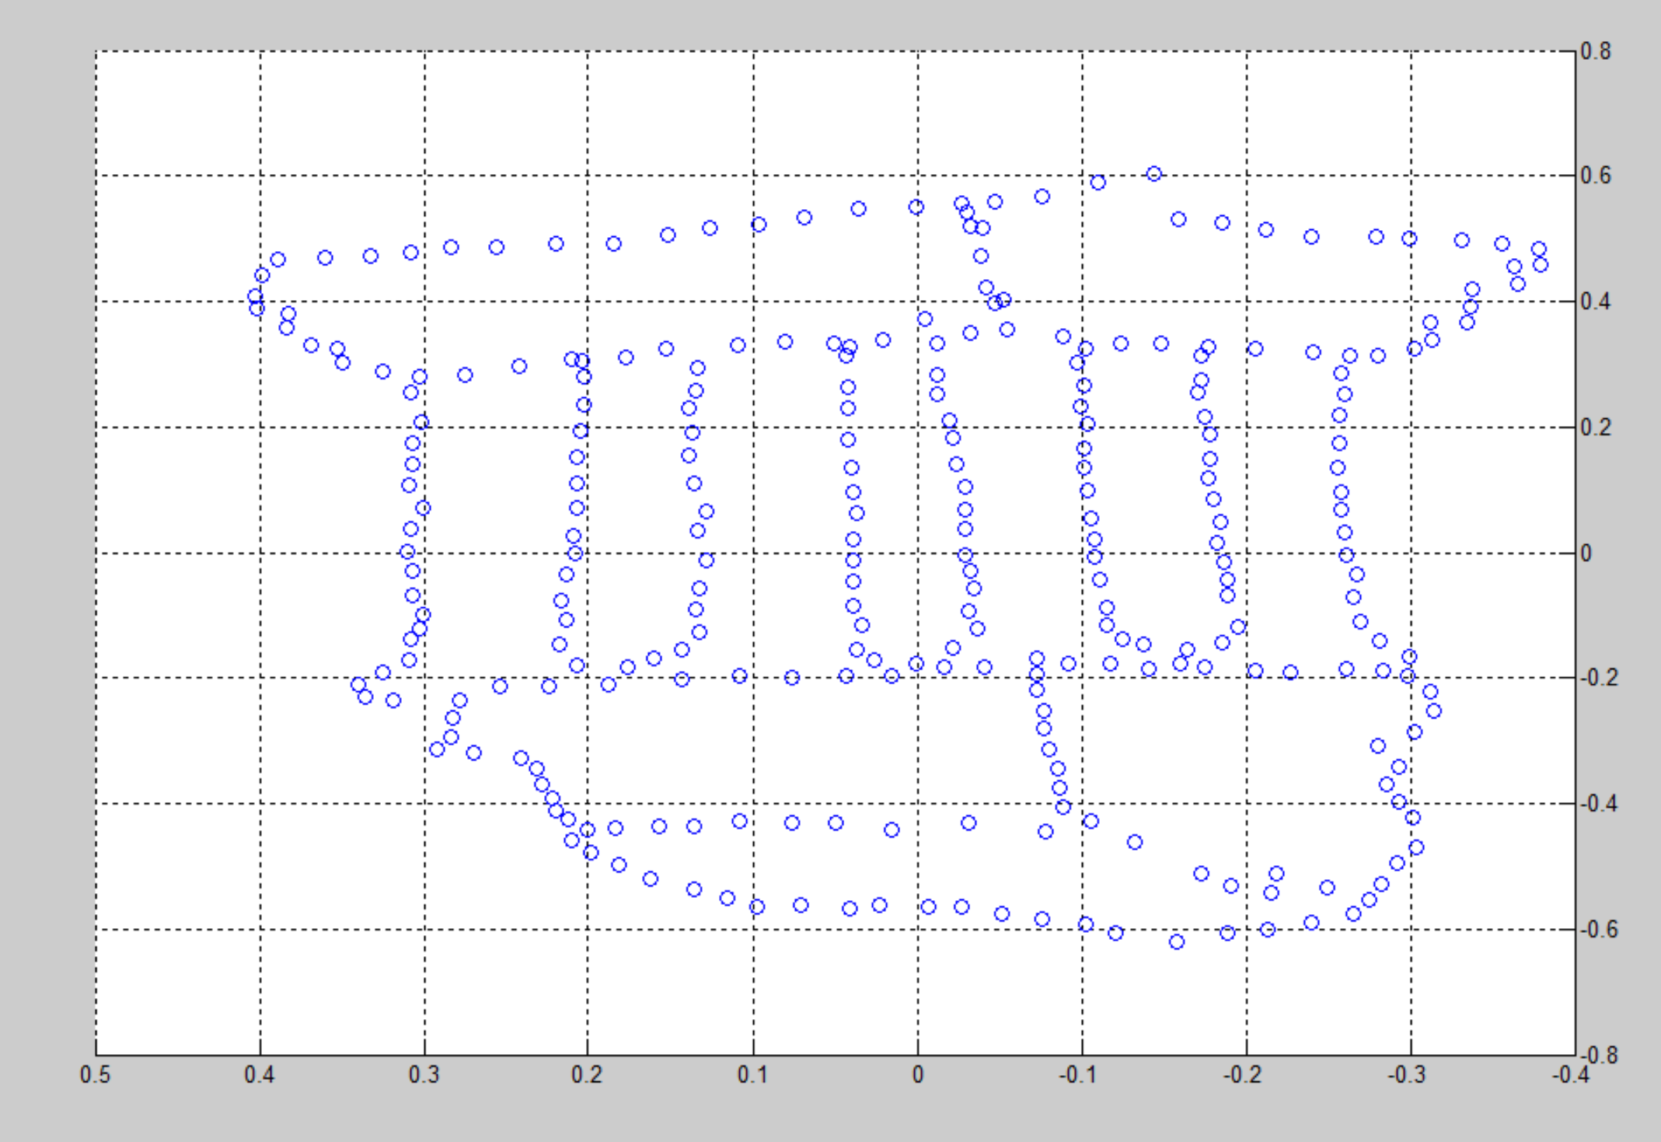

Figure 8

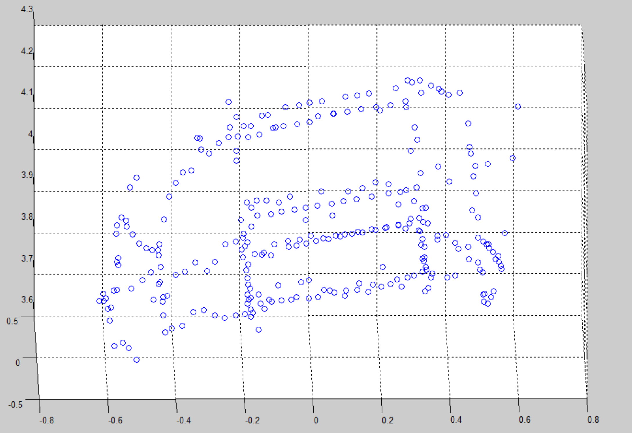

Figure 9

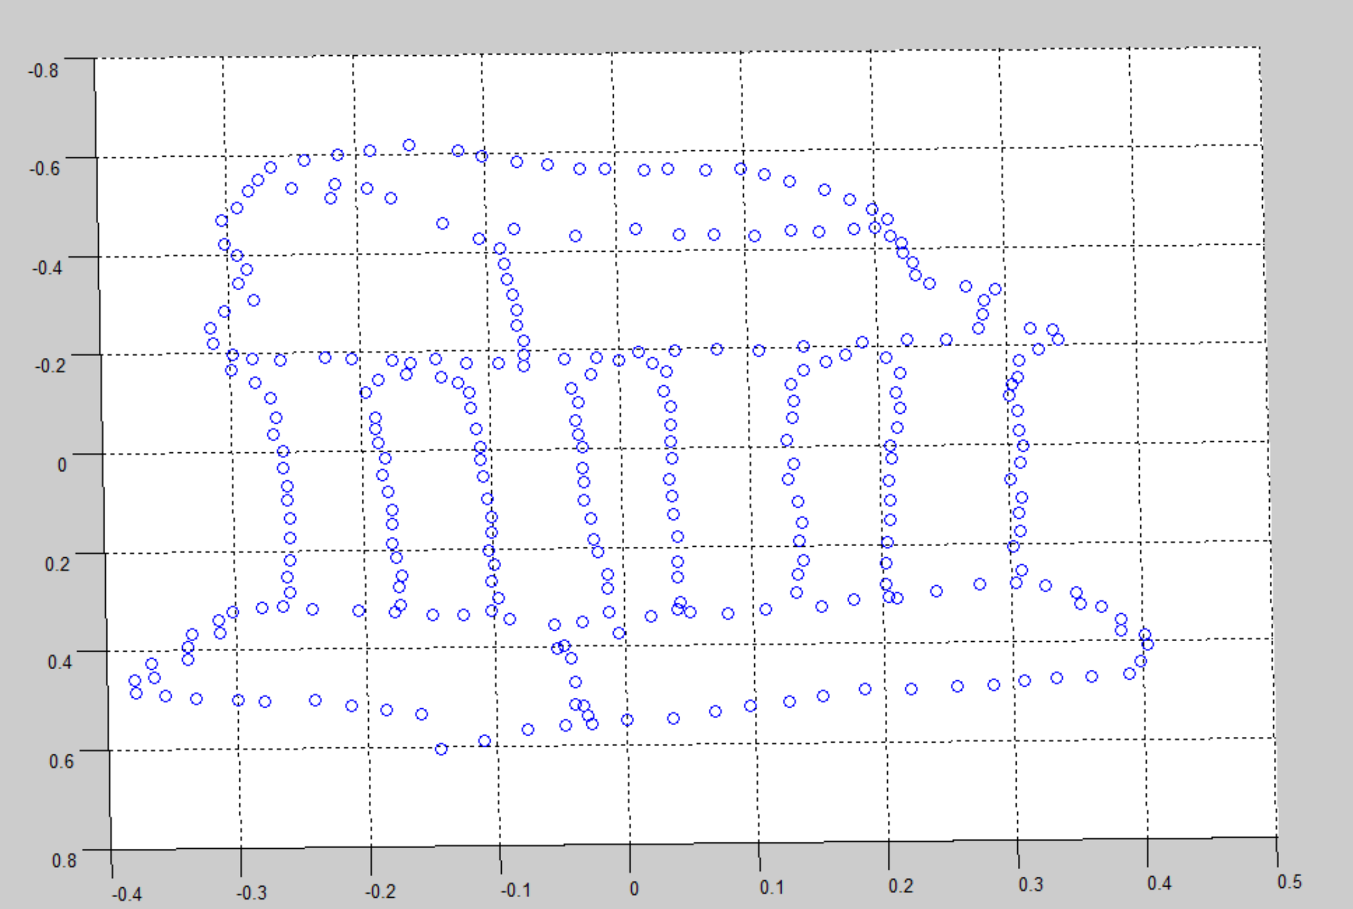

Figure 10

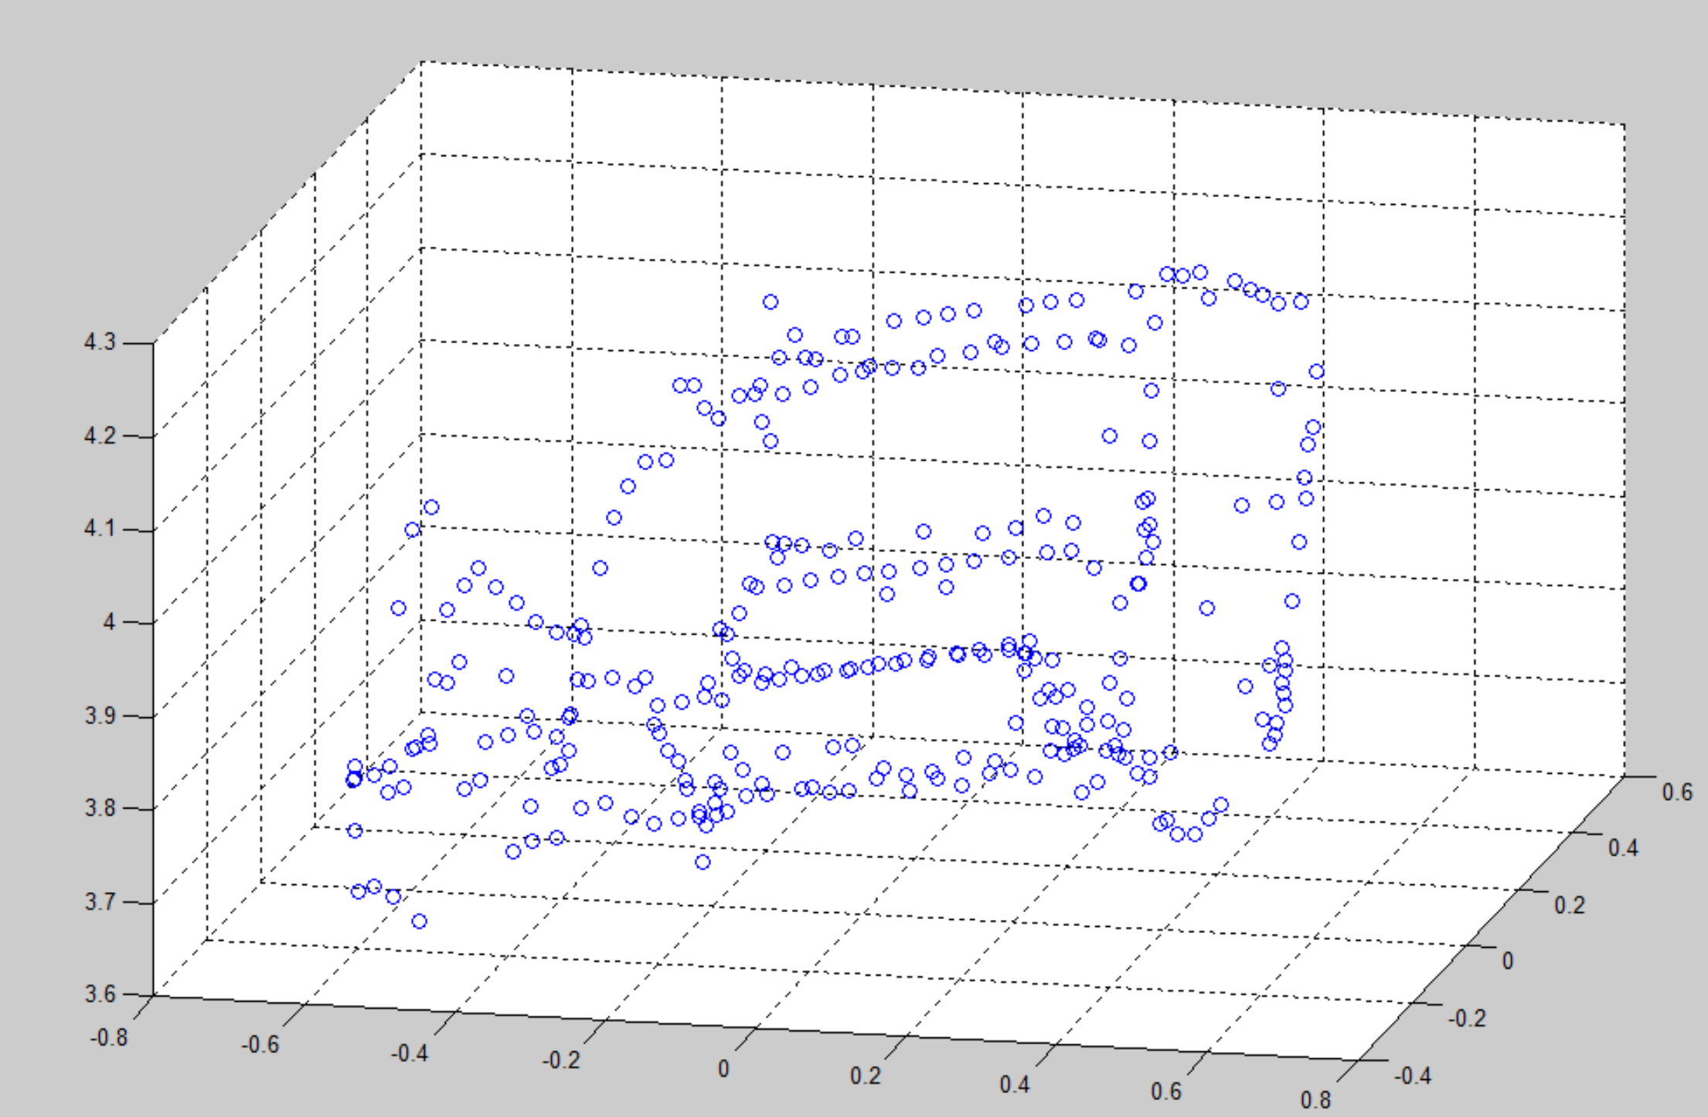

Figure 11

QX (Extra)

For this extra part, I found very useful tutorial on <http://www.mathworks.com/help/vision/examples/structure-from-motion-from-two-views.html>

And the basic idea is to get more points involved in this reconstruction process and record the pixel value of each points on image. And I used functions in 3-D Point Cloud Processing in **MATLAB 2016a Computer Vision System Toolbox** to generate much better visualization effects! Please see the following pictures:

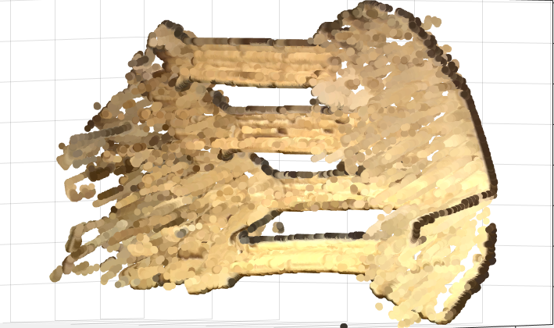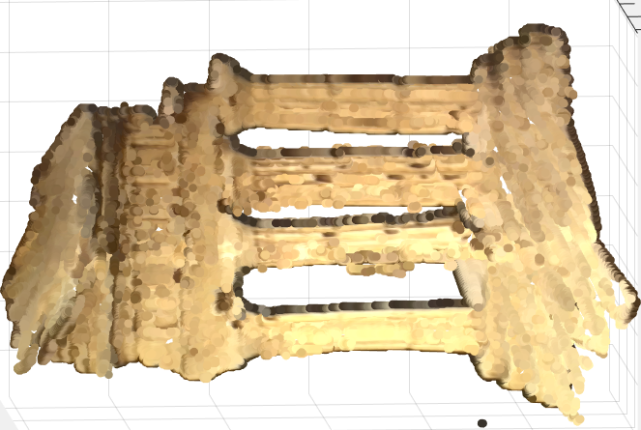

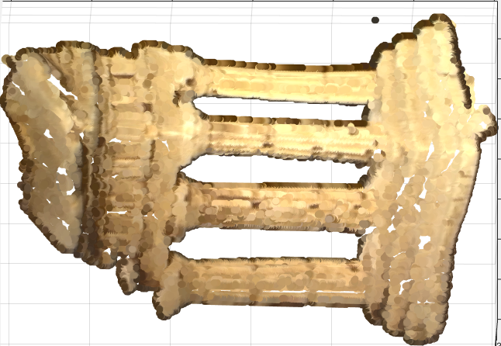

Note: please refer to Q_X.m for detailed code. This may take long time to process and need to be tested on Matlab 2016a/2016b version. Thank you for this amazing homework!